FAKE API – json-server

Website Link : https://www.npmjs.com/package/json-server
Repository/Documentation : https://www.npmjs.com/package/json-server

About :
- Json-server provides a full fake REST API and database in local machine for quick
backend .
- It creates a db.json file on local machine, using lowdb that act as a database, and when make POST, PUT, PATCH or DELETE requests, changes will be automatically and safely saved to it.
- Id values are not mutable. Any id value in the body of your PUT or PATCH request will be ignored. Only a value set in a POST request will be respected, but only if not already taken
- You can access your fake API from anywhere using CORS and JSONP.

Resources:

Serial No. | APIs
1 | http://localhost:3001/posts
2 | http://localhost:3001/comments
3 | http://localhost:3001/profile

Note: All the apis will run on the localhost after running the server.

Routes
- All HTTP methods are supported. You can use http or https for your requests.

Serial No. | Method | Endpoint | Data
1 | GET | /posts | Fetch all the posts available
2 | GET | /posts/1 | Only fetch the post for the given post id in the endpoint.
5 | POST | /posts/1 | Create a new post with the post data passed in the body of the POST request.
6 | PUT | /posts/1 | Modify the post's details of the given post id
8 | DELETE | /posts/1 | Delete the post with the given post id
9 | GET | /profile | Fetch the profile
10 | POST | /profile | Create new profile
11 | PUT | /profile | Update profile

Paginate
Use ”_page” and optionally “_limit” to paginate returned data.
In the Link header you'll get first, prev, next and last links.

GET /posts?_page=7
GET /posts?_page=7&_limit=20

10 items are returned by default

Sort
Add “_sort” and “_order” (ascending order by default)

GET /posts?_sort=views&_order=asc
GET /posts/1/comments?_sort=votes&_order=asc

For multiple fields, use the following format:
GET /posts?_sort=user,views&_order=desc,asc

Note : For More go through the documentation

PROJECT – Listing App

About :
It's a simple listing app, which will be using the apis to get the fake/dummy data from the JSONPlaceholder and presenting the data on our app. It has been built on ReactJS with different libraries like axios for http request handling, react-paginate to add pagination and bootstrap for styling.

Create Project
- Create a new react project via CLI i.e., create react app or create vite, command – npx create-react-app project_name, npm create vite project_name.
- This project has been built via create vite.
- Perform code cleanup, deletes unnecessary files.
- Install the following libraries –json-server, react-paginate, react-bootstrap, bootstrap & axios.
- Create a Folder components in src in which we will create the components.
- Start the server bia command – json-server -p 3001 –watch db.json.

- The above command will statrt the server on local machine and create a new db.json file, if not created. Also, the port can be change by changing “-p PORT_NUMBER”.
- Run the react app – npm run dev.

Folder Structure:
Project Folder
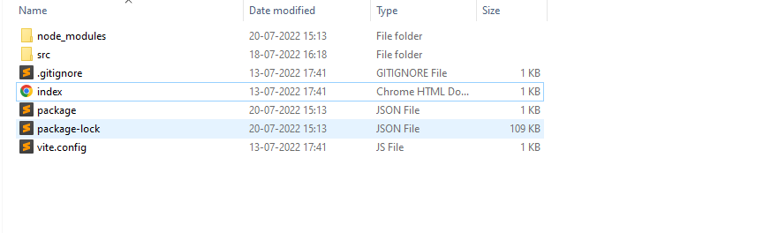
src Folder
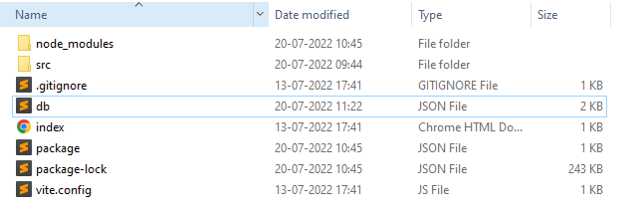

components Folder
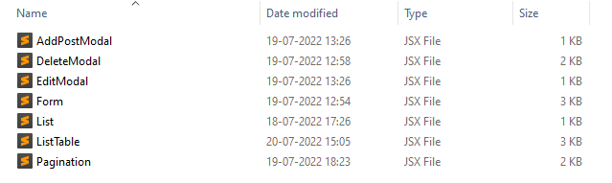

Description
In our component folder we have 7 components :
- AddPostModal – A simple modal which will allow user to add a new record.
- EditModal – A simple modal which will allow user to edit an existing record.
- DeleteModal – A simple modal which will confirm user's action to delete a record.
- Form – A simple html form embeded inside the modal, which will display the fields of the records along with the appropriate label.
- ListTable – A html table to display the records on the screen.It
consists of List components.
- List – This component generates table row for the data received from the api.
- Pagination – This component is handling the pagination of the app and the number of List component to show on the ListTable.

Other Important Files :
- Main.jsx – This file contains the ReactDom component which takes App.jsx as it's child component. Whatever component is passed as a child component to ReactDom, will be display on the screen.
- App.jsx – App.jsx is the main component of a react app. It's the only component which is read by react-dom and imported inside the main.jsx file to render it on the screen. Components should be use inside this file.
- Package.json – This file contains the meta data and all the dependencies/libraries used in the react-app.
- Vite.config – It contains configuration of vite tool.

App.jsx
In App.jsx we have Container component from react bootstrap with some classes applied on it and inside that we have our ListTable component which is generating the
data List on screen.

import './App.css'
import ListTable from './components/ListTable'
import { Container } from 'react-bootstrap'
import 'bootstrap/dist/css/bootstrap.min.css';

function App() {
return (
<div className="App">
<Container className='mt-5 col-12'>
<ListTable/>
</Container>
</div>
)}

export default App

ListTable Component

import { useEffect, useState } from 'react';
import Table from 'react-bootstrap/Table';
import List from './List';
import axios from 'axios'
import EditModal from './EditModal';
import DeleteModal from './DeleteModal';
import { Button, Container } from 'react-bootstrap'
import AddPostModal from './AddPostModal'
import Pagination from './Pagination';

const ListTable = ()=> {

//store the data from the api and generate an array of List component
const [AllPosts,setAllPosts] = useState([]);
//stores the array of List component generated by getLists function
const [posts,setPosts] = useState([]);
//stores & display the array of List component according to the items per page range and updates on pagination
const [lists,setLists] = useState(null)
//stores the post which needs to be edited or deleted
const [changePost,setChangePost] = useState(null);
const [showEditModal,setShowEditModal] = useState(false);
const [showDeleteModal,setShowDeleteModal] = useState(false);
const [showAddPostModal,setShowAddPostModal] = useState(false);

const setPostsPerPage = (items)=>{
setPosts(items)
}

const showEditModalHandler = (post)=>{
setShowEditModal(true);
//save post which needs to be change or edit
setChangePost(post)
}

const showDeleteModalHandler = (post)=>{
setShowDeleteModal(true);
//save post , needs to be deleted
setChangePost(post)
}

//function that returns an array of List component with api's data
const getLists = ()=>{
return AllPosts&&AllPosts.map((post,id)=>(
<List showEditModal={()=>showEditModalHandler(post)} showDeleteModal={()=>showDeleteModalHandler(post)} key={id} post={post} serialNo={id}/>
))
}

useEffect(()=>{
setLists(getLists())
},[AllPosts])

useEffect(()=>{
//call the api whenever modal is closed to get the new modified/deleted data
if( !showEditModal && !showDeleteModal && !showAddPostModal){
axios.get('http://localhost:3001/posts')
.then(res=>setAllPosts(res.data))
}
},[])

return (
<>
<Container className='d-flex my-5 align-items-center justify-content-center'>
<Button onClick={()=>setShowAddPostModal(true)} variant='outline-dark'>Add Post</Button>
</Container>
<Table striped bordered hover responsive>
<thead>
<tr>
<th className='text-center'>Serial No.</th>
<th className='text-center'>Author</th>
<th className='text-center'>Title</th>
<th className='text-center'>Controls</th>
</tr>
</thead>
<tbody>
{
posts
}
</tbody>
</Table>
<EditModal post={changePost} show={showEditModal} onHide={()=>setShowEditModal(false)}/>
<DeleteModal post={changePost} show={showDeleteModal} onHide={()=>setShowDeleteModal(false)}/>
<AddPostModal postid={parseInt(AllPosts[0]?.id)+1} show={showAddPostModal} onHide={()=>setShowAddPostModal(false)}/>
<Pagination items={lists} setPaginationItems={setPostsPerPage} itemsPerPage={5}/>
</>
);
}

export default ListTable;

List Component

import { Button } from 'react-bootstrap'

const List = ({post, showEditModal, showDeleteModal})=>{

return(
<tr>
<td className='text-center'>{serialNo+1}</td>
<td className='text-center'>{post.author}</td>
<td className='text-center'>{post.title}</td>
<td className='d-flex align-items-center justify-content-around' >
<Button className='w-25' onClick={showEditModal} variant='outline-primary'>Edit</Button>
<Button className='w-25' onClick={showDeleteModal} variant='outline-danger'>Delete</Button>
</td>
</tr>
)
}

export default List;

EditModal Component

import {Modal} from 'react-bootstrap';
import PostForm from './Form';

const EditModal = (props)=> {

return (
<Modal {...props} contentClassName=" mx-auto w-75" aria-labelledby="contained-modal-title-vcenter" centered>
<Modal.Header className='bg-primary text-white' closeButton closeVariant='white'>
<Modal.Title id="contained-modal-title-vcenter">
Edit Post
</Modal.Title>
</Modal.Header>
<Modal.Body>
<PostForm editModal post={props.post} onHide={props.onHide}/>
</Modal.Body>
</Modal>
);
}

export default EditModal;

DeleteModal Component

import {Modal, Button} from 'react-bootstrap';
import axios from 'axios'
import PostForm from './Form';

const DeleteModal = (props)=> {
const deleteListHandler = ()=>{
axios.delete(`https://jsonplaceholder.typicode.com/posts/${props.post.id}`)
.then(res=>props.onHide())
}

return (
<Modal {...props} centered>
<Modal.Header className='text-white bg-danger' closeButton closeVariant='white'>
<Modal.Title>Delete Record</Modal.Title>
</Modal.Header>
<Modal.Body>
<h6>Are you sure, you want to delete this record ?</h6>
</Modal.Body>
<Modal.Footer className='d-flex align-items-center justify-content-evenly' >
<Button className='w-25' variant="danger" onClick={deleteListHandler}>
Yes
</Button>
<Button className='w-25' variant="secondary" onClick={props.onHide}>
No
</Button>
</Modal.Footer>
</Modal>
);
}
export default DeleteModal;

AddPostModal Component

import { Modal} from 'react-bootstrap';
import PostForm from './Form';

const AddPostModal = (props)=>{

return(
<Modal {...props} contentClassName=" mx-auto w-75" centered>
<Modal.Header className='bg-dark text-white' closeButton closeVariant='white'>
<Modal.Title>Add Record</Modal.Title>
</Modal.Header>
<Modal.Body>
<h6>Please fill the below details :</h6>
<PostForm postid={props.postid} onHide={props.onHide}/>
</Modal.Body>
</Modal>
)
}

export default AddPostModal;

Form Component

import { Form, Row, Col, Modal, Button } from 'react-bootstrap'
import { useEffect, useState } from 'react';
import axios from 'axios'

const PostForm = (props)=>{

const [post,setPost] =useState({
id : props.editModal?props.post?.id:props.postid,
author : props.editModal?props.post?.author:'',
title : props.editModal?props.post?.title:''
})

const changeInputHandler = (e,field)=>{
switch(field){
case 'title' : setPost({...post, title : e.target.value});break;
case 'author' : setPost({...post, author : e.target.value});break;
}
}

const submitButtonHandler = (event)=>{
event.preventDefault();

if(props.editModal){
axios.put(`http://localhost:3001/posts/${props.post.id}`,post)
.then(res=>props.onHide())
}
else{
axios.post('http://localhost:3001/posts',post)
.then(res=>props.onHide())
}

}

return(
<Form className={!props.editModal?'mt-3 border p-2':null}>
<Form.Group as={Row} className='mb-2'>
<Form.Label column sm='2'>
<h6>Title</h6>
</Form.Label>
<Col sm='10' md='50'>
<Form.Control className='w-100' value={post.title} onChange={(event)=>changeInputHandler(event,'title')}></Form.Control>
</Col>
</Form.Group>
<Form.Group as={Row} className='mb-1'>
<Form.Label column sm='2' md='50'>
<h6>Author</h6>
</Form.Label>
<Col sm='10'>
<Form.Control className='w-100' value={post.author} onChange={(event)=>changeInputHandler(event,'author')}></Form.Control>
</Col>
</Form.Group>
<Form.Group className='text-end mt-3'>
<Button className='mx-auto' variant={props.editModal?'primary':'dark'} type='submit' onClick={submitButtonHandler}>Submit</Button>
</Form.Group>
</Form>
)

}

export default PostForm;

Pagination Component

import ReactPaginate from 'react-paginate';
import { useEffect, useState } from 'react';
import { Stack } from 'react-bootstrap';

const PaginatedItems = ({ items, setPaginationItems, itemsPerPage })=>{
// We start with an empty list of items.

const [pageCount, setPageCount] = useState(0);
// Here we use item offsets; we could also use page offsets
// following the API or data you're working with.
const [itemOffset, setItemOffset] = useState(0);
const endOffset = itemOffset + itemsPerPage;

useEffect(() => {
// Fetch items from another resources.
setPaginationItems(items?.slice(itemOffset, endOffset));
setPageCount(Math.ceil(items?.length / itemsPerPage));
}, [itemOffset, itemsPerPage,items]);

// Invoke when user click to request another page.
const handlePageClick = (event) => {
const newOffset = (event.selected * itemsPerPage) % items?.length;

setItemOffset(newOffset);
};

return (
<>
<Stack direction='horizontal'>
<h6 className='mx-auto'>{`Showing ${itemOffset+1}-${endOffset} of ${items?.length} records`}</h6>
</Stack>
<ReactPaginate
className='nav justify-content-center gap-2 mt-2'
pageClassName='d-flex align-items-center'
nextClassName='nav-item btn btn-primary p-0 ms-3'
nextLinkClassName='nav-link text-white'
activeLinkClassName='btn bg-dark text-white'
pageLinkClassName=' h-75 btn btn-sm border-1 border-dark'
breakLabel="..."
nextLabel="next"
onPageChange={handlePageClick}
pageRangeDisplayed={5}
pageCount={pageCount}
previousLinkClassName='nav-link text-white'
previousClassName='nav-item btn btn-dark p-0 me-3'
previousLabel="prev"
renderOnZeroPageCount={null}
/>
</>
);
}
export default PaginatedItems;

Working
Home Screen
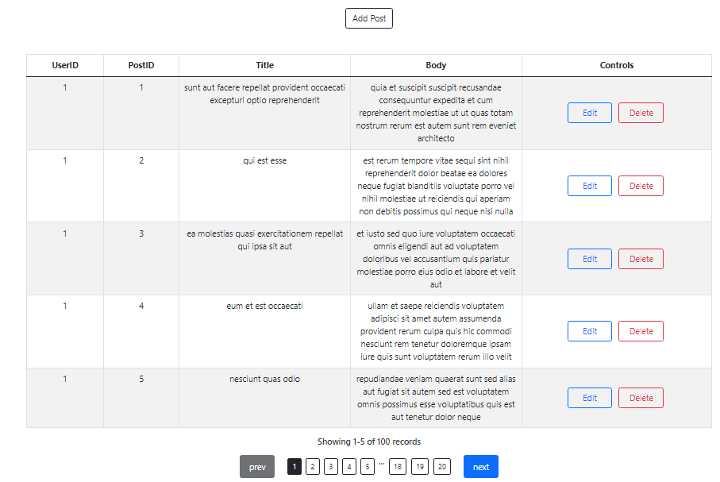

Add Post button
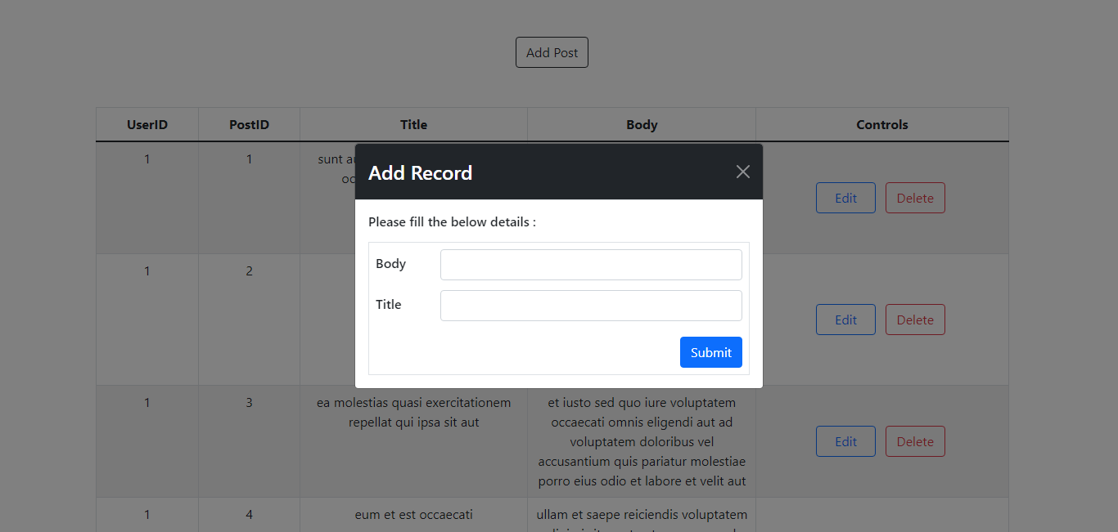
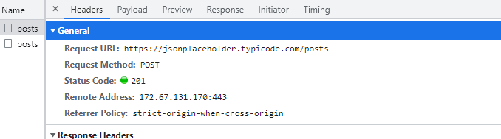
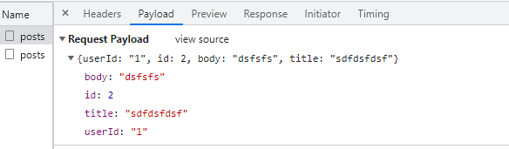

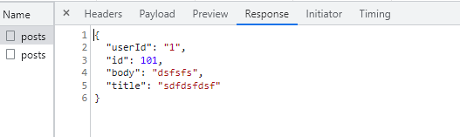

Edit Button
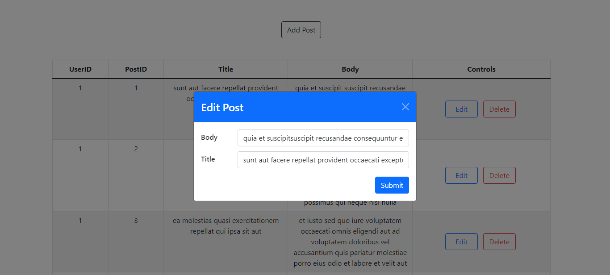
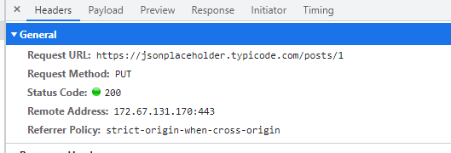

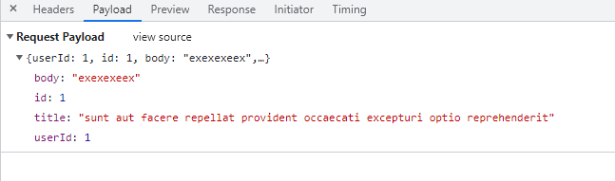

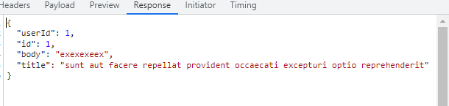

Delete Button
